Fast**National University of Computer & Emerging Sciences, Karachi  
Fall-2023 FAST School of Computing  
Midterm-II**

**8th November 2023, 11:30 am – 12:30am**

**SOLUTION**

|  |  |  |
| --- | --- | --- |
| **Course Code:** CS4101 | **Course Name:** Applied Machine Learning | |
| **Instructor Name:** Mr. M. Shahzad | | |
| **Student Roll No:** | | **Section:** |

**Instructions:**

* Return the question paper and make sure to keep it inside your answer sheet.
* Read each question completely before answering it. There are **three questions and two pages (front plus back)**.
* In case of any ambiguity, you may make assumption. However, your assumption should not contradict any statement in the question paper.
* Do not write anything on the question paper (except your ID and group).

**Total Time:** 1 Hour **Max Points**: 15

------------------------------------------------------------------------------------------------------------------------------------------------

**Question 1: [CNN & Ensemble Learning] [5 points, CLO2, 20 mins]**

1. **[1 point]** Let assume the following function is obtained after training AdaBoost Classifier:

**

Determine the label either 1 or -1 for the test data (i) x=3, (ii) x=6. Show all steps

**Sol.**

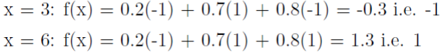

1. **[1 point]** You are solving the binary classification task of classifying images as cat vs. non-cat. You design a CNN with a single output neuron. Let the output of this neuron be ***z***. The final output of your network, is given by:



You classify all inputs with a final value ≥ 0.5 as cat images. What problem are you going to encounter?

**Sol.**

Using ReLU then sigmoid will cause all predictions to be positive (σ(ReLU(z)) ≥ 0.5 ∀z).

1. **[2 point]** You come up with a CNN classifier. For each layer, calculate the number of weights, number of biases and the size of the associated feature maps. The notation follows the convention:
   1. CONV-*K-N* denotes a convolutional layer with *N* filters, each them of size *K×K*, Padding and stride parameters are always 0 and 1 respectively.
   2. POOL*-K* indicates a *K × K* pooling layer with stride *K* and padding 0.
   3. FC*-N* stands for a fully-connected layer with *N* neurons.

|  |  |  |
| --- | --- | --- |
| **Layer** | **Activation Shape** | **# of weights** |
| INPUT | 128 x 128 x 3 | 0 |
| Conv-9-32 |  |  |
| POOL-2 |  |  |
| Conv-5-64 |  |  |
| POOL-2 |  |  |
| Conv-5-64 |  |  |
| POOL-2 |  |  |
| FC-3 |  |  |

Note:

* If a matrix *nxn* is convolved with *fxf* filter/kernel and padding *p* and stride *s* then it gives us output matrix with size (n+2p-f)/s + 1, (n+2p-f)/s + 1.
* The method of calculating pooling layer is as same as the Conv layer.

**Sol.**

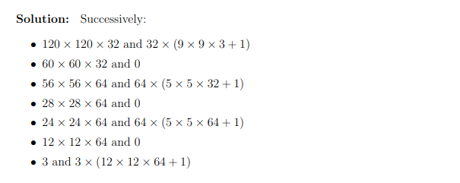

**Question 2: [Linear & Logistic Regression] [5 points, CLO2, 20 mins]**

**1.** The article “Improving Fermentation Productivity with Reverse Osmosis” (Food Technology [1984]: 92– 96) gave the following data on y = glucose concentration (g/L) and x = fermentation time (days) for a blend of malt liquor.

*x* 1 2 3 4 5 6 7 8

*y* 74 54 52 51 52 53 58 71

(a) **[2 points]** Use the data to calculate the estimated regression line. The equation to calculate β0 and β1 is provided in the question paper.

(b) **[1 points]** Using the estimated regression line of Part (a), compute the residuals and construct a plot of the residuals versus x (that is, of the (x, residual) pairs).

(c) **[1 point]** Briefly discuss with justification whether the logistic regression can be used to train the model for dataset given in this question.

**EQUATIONS PROVIDED**

For finding the weights for linear regression

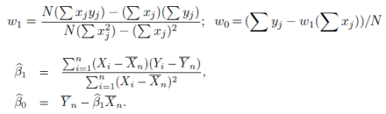

**Solution:**

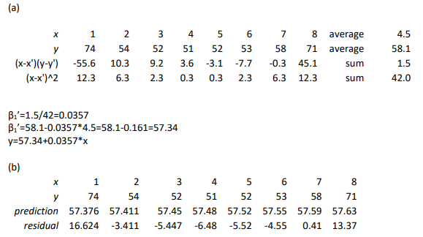

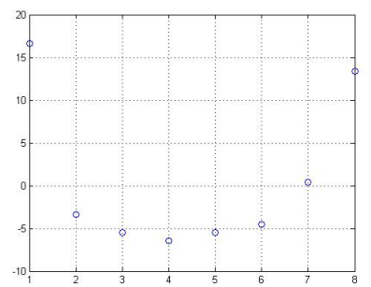

(c) Logistic regression cannot be used as logistic regression outputs either 0 and 1, and hence can be used for binary classification problem.

**2. [1 point]** Draw a Logistic Loss plots for both correct and incorrect prediction.

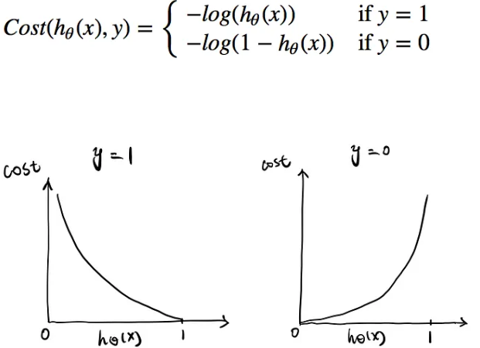

**Question 3: [Neural Network] [5 points, CLO2, 15 mins]**

For the following neural network, with initial randomized weights ***w1*** & ***w2*** and bias ***b*** given as follow:

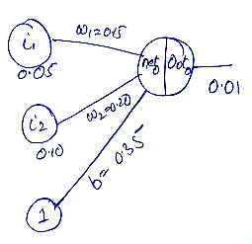

Run the backpropagation algorithm for the input ***i1*** & ***i2***, assuming the sigmoid function for all the activation functions, and assuming a learning rate of 0.5.

The sigmoid function is given as:



**Solution:**

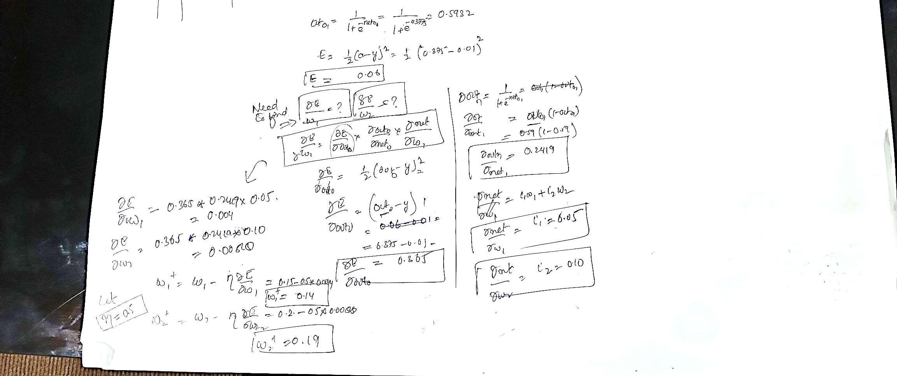

**Question 3: [CNN] [5 points, CLO2, 15 mins]**

For the following neural network, with initial randomized weights ***w1*** & ***w2*** and bias ***b*** given as follow:

**BEST OF LUCK!**